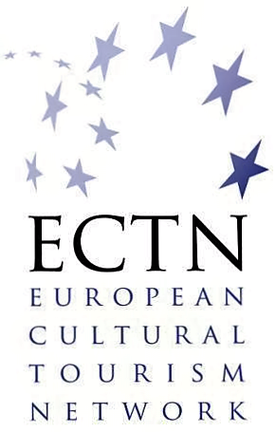

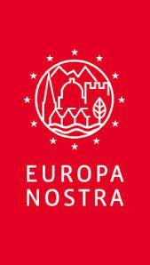
Awards
Awards

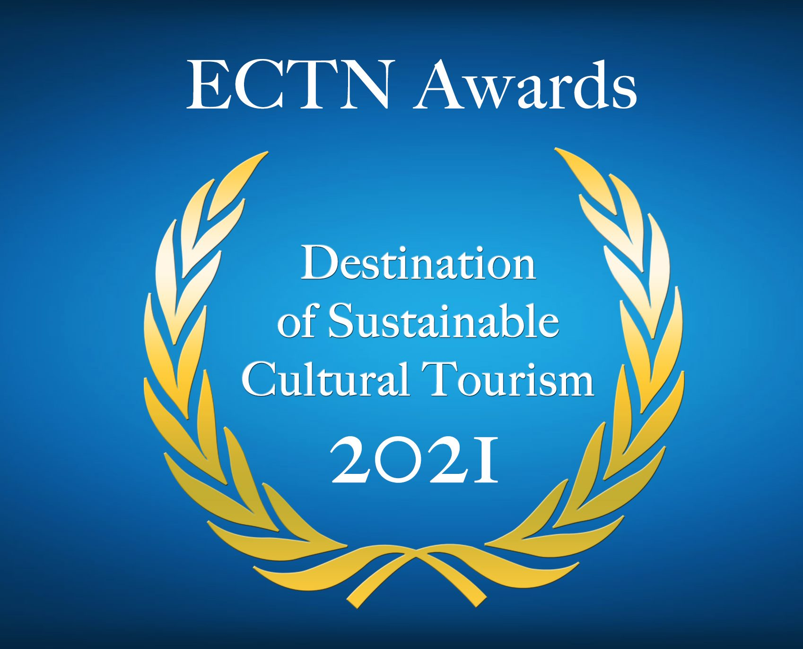

Regenerating European Tourism
through Culture, Heritage and Creativity

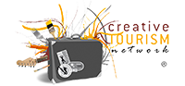
in partnership with:
Supported by:

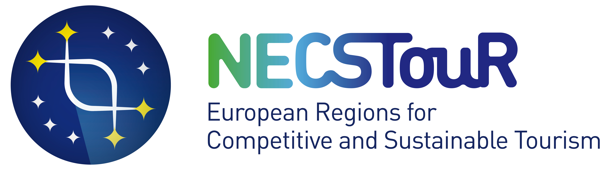
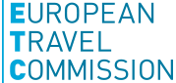

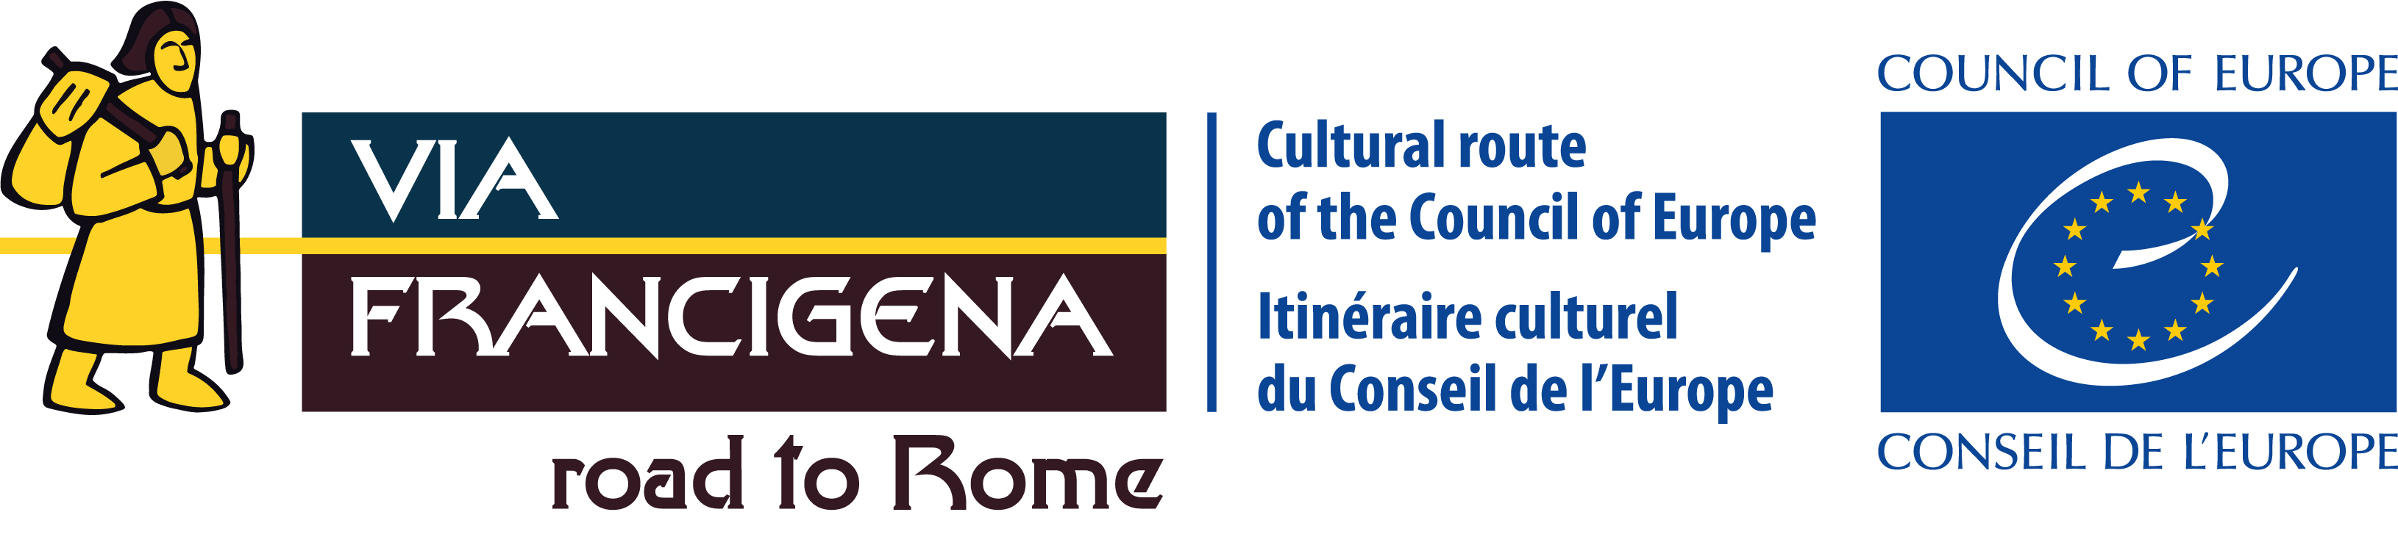

Application form

This application form should be sent by 1 June 2021 / 17.00 CET (Central European Time)
to: awards@culturaltourism-net.eu

Definitions:
Sustainable Cultural Tourism is the integrated management of cultural heritage and tourism activities in conjunction with the local community, creating social, environmental and economic benefits for all stakeholders in order to achieve tangible and intangible cultural heritage conservation and sustainable tourism development. (European Commission DG EAC, OMC Report 2019)
Sustainable Tourism is tourism that takes full account of its current and future economic, social and environmental impacts, addressing the needs of visitors, the industry, the environment and host communities. (UNWTO)

PART 1 Title, Category and Summary

TITLE of the Application (short title of the achievement in one line maximum)

Which of the Awards 2021 categories is most applicable to your application?
(please, tick only one box)

☐ Archaeological Sites and Museums as Cultural Tourism Attractions

☐ Walking Tourism and Slow Travel – Synergies with Cultural Tourism

☐ Digitalisation in Sustainable Cultural Tourism, towards Smart Destinations

☐ Transnational Thematic Tourism Products, including European Cultural Routes

☐ Cultural and Creative Industries (CCIs) contribution to Cultural and Creative Tourism development

☐ Railway Heritage Assets for Cultural Tourism

SUMMARY of the Application
(describe the achievement in 100 words maximum, this summary will be published)

PART 2 Candidate details

LOCATION  INFORMATION | The initiative, action, project, strategy etc. (see title provided under part 1) is implemented in:
 | Tourist destination
 | Region
 | Country

CONTACT DETAILS  (of the legal representative of the destination or attraction, action, initiative) | Name  (title, first name, surname)
 | Function
 | Organisation
 | Address
 | Telephone
 | Mobile phone
 | Email
 | Website

PROJECT MANAGER (if not identical to the legal representative) | Name (title, first name, surname)
 | Function
 | Organisation
 | Address
 | Telephone
 | Email
 | Website

PART 3 Statement

This statement should briefly describe the aims and content of the candidate project, action, initiative etc., within the selected category of sustainable cultural tourism, the partners involved, the implementation process, any budgetary constraints, phases of development, events, and the qualities which make it outstanding in a European context 1000 words maximum

PART 4 Evidence of Success

In this section, the candidate should present the achievements and results of the project, action, initiative, etc. The candidate is strongly encouraged to include information about the following metrics:
- Key Performance Indicators achieved
- Tourism indicators, such as:
  - number of visitors (in particular during the low season)
  - increase in the average spend / spend on local products due to the action
  - visitor satisfaction.
1000 words maximum

PART 5 Supporting Materials

This section should include links to: Location Plan (if applicable, preferably to the scale of 1:10 000, on which the site is clearly marked), documentation (regional and state policies, destination, project, initiative etc.), latest report summary, presentations (with information regarding where and to whom this was presented), video online, etc. To complete the dossier, please, reference to this section all supporting materials with valid online links. 1 page maximum

Photographs
Good quality colour photos (10 maximum) clearly showing the overall situation and important details of the submitted project, initiative, action, etc. with references to sources online. If applicable, photos can include BEFORE and AFTER views, preferably from the same viewpoint, laid out together in the dossier. Wherever possible, please include photos of the work(s) in progress. All photos should be clearly captioned. Please provide links online:

Video and documentaries
Latest video and documentaries (if applicable) in good quality with reference to sources of the submitted projects, actions, initiatives etc. (online, URL) maximum 3 links:

Publications / Articles appeared in media
Links to the articles published in the media between the period 2018-2021 (3 maximum):

Communication
Social media accounts dedicated to the initiative (please provide links):

Please ensure that any web links are clickable and active, any problematic links cannot be taken into account by the Jury. Do not send any other separate files, they will not be considered by the Jury.

Awards Criteria

The Awards Jury will assess the quality of applications according to the following criteria:

Relevance to the selected category and content quality
- Evidence of success (numbers of visitors, visitor satisfaction, publicity)
- Tourism Sustainability – Sustainable Development of Tourism (Economic, Social, Environmental)
- Ability to attract visitors from outside Europe and to lesser known destinations
- Innovative character
- Involvement of the local community
- Contribution to EU Green Deal and Climate Action (SDG 13)
- Inclusive Tourism aspects (facilitating family holidays, social tourism)
- Mitigating the impacts of the pandemic crisis, for resilience and recovery (only for projects finalised in 2020 and 2021).

Check-list

Please check that you have completed all sections of the form - the checklist below should help you ensure your application is complete:

Application form

- only one Awards category has been selected
- all fields have been completed
- the application is written in English
- the links provided in the form are active and clickable (see part 5)
- links to max. 10 photos are included (see part 5)
- links to max. 3 videos are included, if applicable (see part 5)
- links to max. 3 publications or articles are included (see part 5)
- the maximum limits have been respected

Declaration

- the separate Declaration form has been filled in, is signed and stamped (scanned version or with digital signature)

Applications that fail to fulfil all requirements will not be considered by the Jury.

Information on the Processing of Personal Data Pursuant to the Regulation (EU) 2016/679 (GDPR)

ECTN informs all applicants for the Awards 2021, pursuant to the Regulation (EU) 2016/679 and the relevant legislation in force with regard to the protection of personal data, in its capacity as organiser, that it processes personal data, collected either with the submission of an application, or at a later time, including data derived from a participants list, or in the framework of external relations, in compliance with GDPR requirements. In particular, where ECTN has requested and received applicants’ consent the processing of data is based on this consent. In such cases applicants have the right to withdraw their consent at any time. However, the processing based on any consent prior to withdrawal remains unaffected. ECTN takes appropriate technical and organizational measures to ensure the security and confidentiality of applicants’ personal data, their processing and protection from accidental or unlawful destruction, loss, alteration, prohibited transmission, dissemination or access and any other form of unlawful processing.

Please submit this form together with the separate signed ‘Declaration’ form.

